**Background Verification Consent Form**

I __________­­­­­­­­­­­­­­­­­­­­Jayashree R________ ______________________________,

Last name First name Middle name

hereby authorize <**Tech Mahindra Limited>,** hereafter referred to Tech Mahindra, or a third party agency/agent engaged by Tech Mahindra to contact any former employers as indicated in the Application Form / Resume and carry out all background checks, not restricted to education and employment, deemed appropriate through the selection procedure.

I authorize former employers, agencies and educational institutes etc., to release any information pertaining to my employment / education and I release them from any liability in doing so.

I confirm that the information provided by me in the Application Form / Resume is true and correct. I understand that any misrepresentation of information or providing wrong information in the Application Form / Resume may, in the event of being employed by Tech Mahindra, result in disciplinary action by Tech Mahindra based on its then current policies, which may include termination for cause.

Signature: 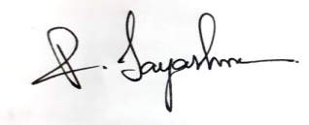 Date 04/05/22

(DD / MMM / YYYY)